**EX -1** **Impute missing values in data inputs**

**Aim:**

To Implement missing values in data input

**Program:**

import pandas as pd

import numpy as np

null_values=pd.Series([1,np.NaN,2,np.NaN,4,5])

null_values

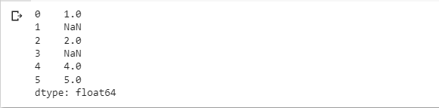

null_values.isna()

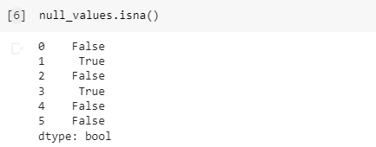

null_values.notna()

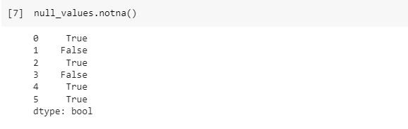

null_values.fillna(0)

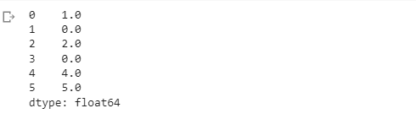

null_values.fillna(np.mean(null_values))

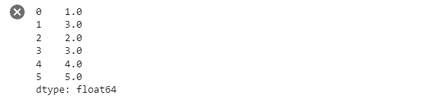

null_values.interpolate()

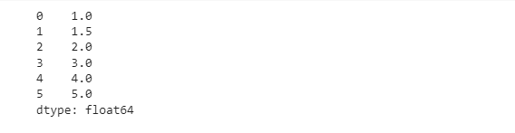

**Result:**

**EX -2** Use feature selection/extraction method to perform dimensionality reduction

**Aim:**

To use feature selection/extraction method to perform dimensionality reduction

**Program:**

from google.colab import files

uploaded =files.upload()



from pandas import read_csv

from numpy import set_printoptions

from sklearn.feature_selection import SelectKBest

from sklearn.feature_selection import f_classif

filename = '/content/pima-indians-diabetes.csv'

# names =['preg','plas','pres','skin','test','mass','pedi','age','class']

dataframe = read_csv(filename,names=names)

dataframe

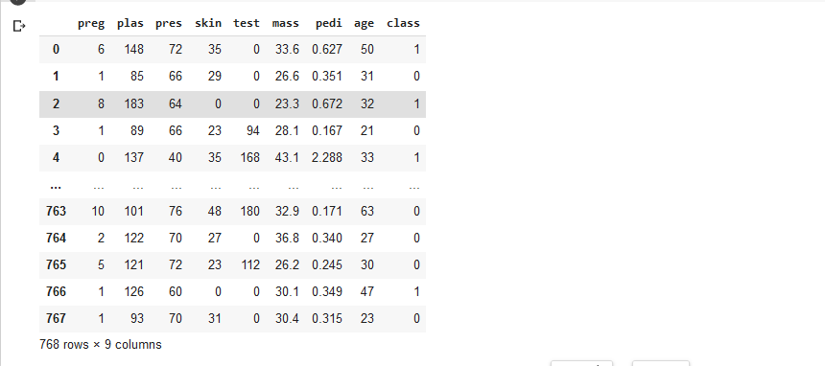

array = dataframe.values

X=array[:,0:8]

Y=array[:,8]

test = SelectKBest(score_func=f_classif,k=4)

fit = test.fit(X,Y)

set_printoptions(precision=3)

print(fit.scores_)

features = fit.transfrm(X)

# summarize selected features

print(features[0:5,:])



**Result:**

**EX -3** Demonstrate Naïve Bayes Classification

**Aim:**

To demonstrate Naïve Bayes Classification.

**Program:**

#load the iris ataset

from sklearn.datasets import load_iris

iris = load_iris()

#store the feature matrix (x) and response vector (y)

X = iris.data

Y = iris.target

#splitting x and y into training and testing sets

from sklearn.model_selection import train_test_split

X_train,X_test, Y_train, Y_test = train_test_split(X, Y, test_size=0.4, random_state=1)

#training the model on training set

from sklearn.naive_bayes import GaussianNB

gnb = GaussianNB()

gnb.fit(X_train, Y_train)

#making predictions on the testing set

Y_pred = gnb.predict(X_test)

#comparing actual response values (Y_test) with predicted response values (Y_pred)

from sklearn import metrics

print("Gaussian Naive Bayes model accuracy (in %)",metrics.accuracy_score(Y_test, Y_pred)*100)

**Output:**



**Result:**

**EX-4** Classify the input dataset using decision tree

**Aim:**

To classify the input dataset using decision tree

**Program:**

import pandas as pd

from sklearn.tree import DecisionTreeClassifier

from sklearn.model_selection import train_test_split

from sklearn import metrics

from google.colab import files

uploaded=files.upload()



col_names = ['pregnant', 'glucose', 'bp', 'skin', 'insulin', 'bmi', 'pedigree', 'age', 'label']

pima = pd.read_csv("diabetes.csv", header=0, names=col_names)

pima.head()

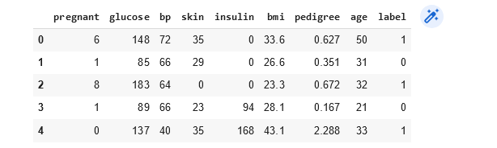

feature_cols = ['pregnant', 'insulin', 'bmi', 'age','glucose','bp','pedigree']

X = pima[feature_cols]

y = pima.label

X_train, X_test, y_train, y_test = train_test_split(X, y, test_size=0.3, random_state=1)

clf = DecisionTreeClassifier()

clf = clf.fit(X_train,y_train)

y_pred = clf.predict(X_test)

print("Accuracy in testing set:",metrics.accuracy_score(y_test, y_pred))



from sklearn.tree import export_graphviz

from six import StringIO

from IPython.display import Image

import pydotplus

dot_data = StringIO()

export_graphviz(clf, out_file=dot_data,

                    filled=True, rounded=True,

                    special_characters=True, feature_names = feature_cols,class_names=['0','1'])

graph = pydotplus.graph_from_dot_data(dot_data.getvalue())

graph.write_png('diabetes.png')

Image(graph.create_png())

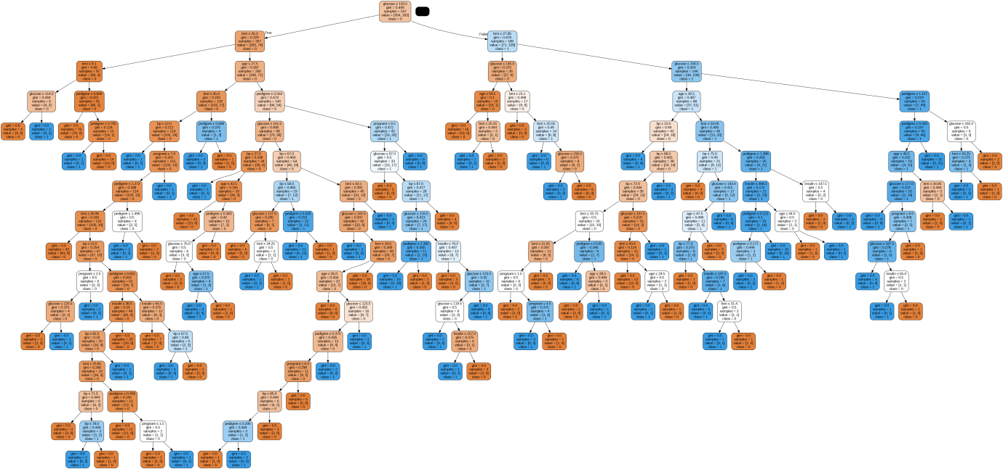

clf = DecisionTreeClassifier(criterion="entropy", max_depth=3)

clf = clf.fit(X_train,y_train)

y_pred_test = clf.predict(X_test)

print("Accuracy:",metrics.accuracy_score(y_test, y_pred_test))



from six import StringIO

from IPython.display import Image

from sklearn.tree import export_graphviz

import pydotplus

dot_data = StringIO()

export_graphviz(clf, out_file=dot_data,

                    filled=True, rounded=True,

                    special_characters=True, feature_names = feature_cols,class_names=['0','1'])

graph = pydotplus.graph_from_dot_data(dot_data.getvalue())

graph.write_png('diabetes.png')

Image(graph.create_png())

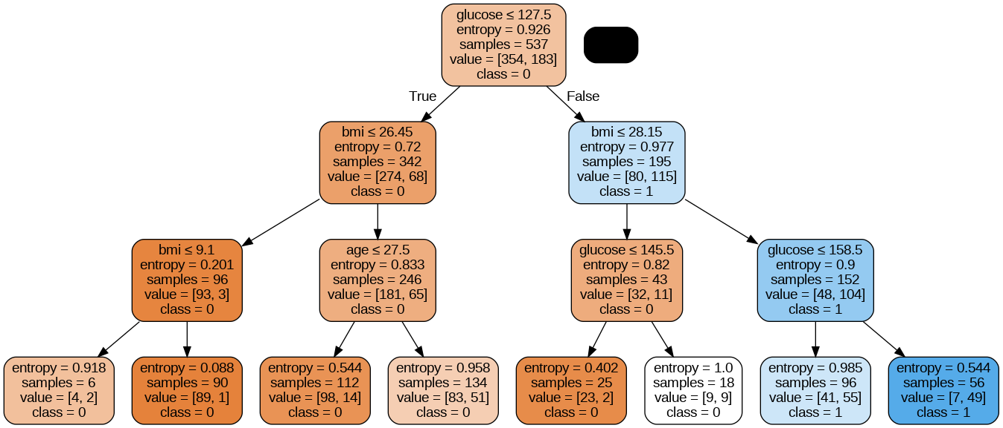

**EX-5** Perform classification using Support Vector Machines

**Aim:**

To Perform classification using Support Vector Machines

**Program:**

import pandas as pd

import numpy as np

import seaborn as sns

import matplotlib.pyplot as plt

from google.colab import files

uploaded=files.upload()



data=pd.read_csv("diabetes.csv")

data.head()

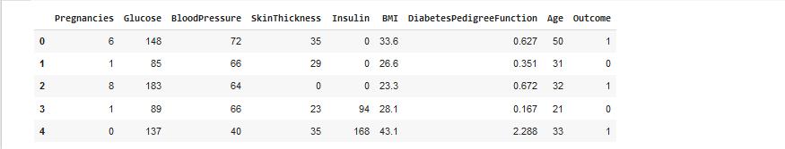

non_zero = ['Glucose','BloodPressure','SkinThickness','Insulin','BMI']

for coloumn in non_zero:

    data[coloumn] = data[coloumn].replace(0,np.NaN)

    mean = int(data[coloumn].mean(skipna = True))

    data[coloumn] = data[coloumn].replace(np.NaN,mean)

    print(data[coloumn])

from sklearn.model_selection import train_test_split

X =data.iloc[:,0:8]

y =data.iloc[:,8]

X_train,X_test,y_train,y_test = train_test_split(X,y,test_size=0.2,random_state=0, stratify=y)

X.head()

0 148.0

1 85.0

2 183.0

3 89.0

4 137.0

...

763 101.0

764 122.0

765 121.0

766 126.0

767 93.0

Name: Glucose, Length: 768, dtype: float64

0 72.0

1 66.0

2 64.0

3 66.0

4 40.0

...

763 76.0

764 70.0

765 72.0

766 60.0

767 70.0

Name: BloodPressure, Length: 768, dtype: float64

0 35.0

1 29.0

2 29.0

3 23.0

4 35.0

...

763 48.0

764 27.0

765 23.0

766 29.0

767 31.0

Name: SkinThickness, Length: 768, dtype: float64

0 155.0

1 155.0

2 155.0

3 94.0

4 168.0

...

763 180.0

764 155.0

765 112.0

766 155.0

767 155.0

Name: Insulin, Length: 768, dtype: float64

0 33.6

1 26.6

2 23.3

3 28.1

4 43.1

...

763 32.9

764 36.8

765 26.2

766 30.1

767 30.4

Name: BMI, Length: 768, dtype: float64

|  |  |
| --- | --- |

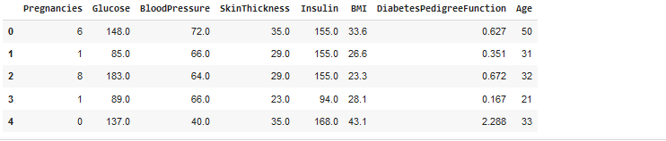

from sklearn.preprocessing import StandardScaler

sc_X = StandardScaler()

X_train = sc_X.fit_transform(X_train)

X_test = sc_X.transform(X_test)

from sklearn import svm

svm1 = svm.SVC(kernel='linear', C = 0.01)

svm1.fit(X_test,y_test)

svm.SVC(C=0.01, kernel='linear')

y_train_pred = svm1.predict(X_train)

y_test_pred = svm1.predict(X_test)

y_test_pred

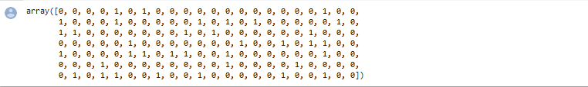 from sklearn.metrics import accuracy_score,confusion_matrix

confusion_matrix(y_test,y_test_pred)

 accuracy_score(y_test,y_test_pred)



**Result:**

**EX-6** Perform multivariate classification and regression

**Aim:**

To Perform multivariate classification and regression

**Program:**

import pandas as pd

import numpy as np

import matplotlib.pyplot as plt

import seaborn as sns

from google.colab import files

upladed=files.upload()

 test=pd.read_csv("california_housing_test.csv")

test.head()

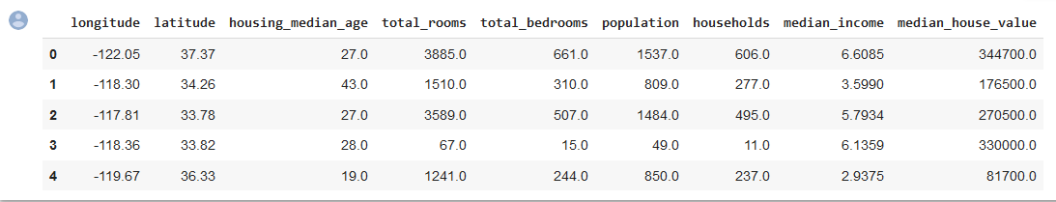 upladed=files.upload()

 train=pd.read_csv("california_housing_train.csv")

plt.figure()

sns.heatmap(train.corr(),cmap='coolwarm')

plt.show()

sns.lmplot(x='median_income',y='median_house_value',data=train)

sns.lmplot(x='housing_median_age',y='median_house_value',data=train)

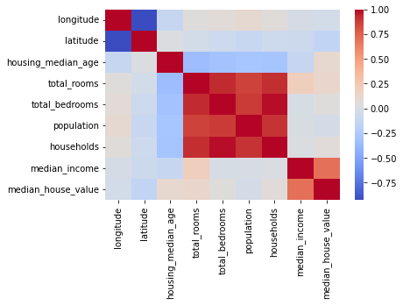 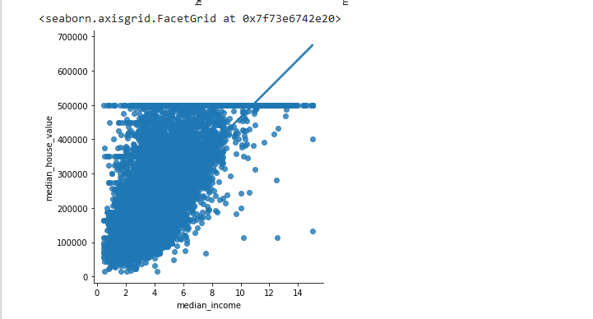 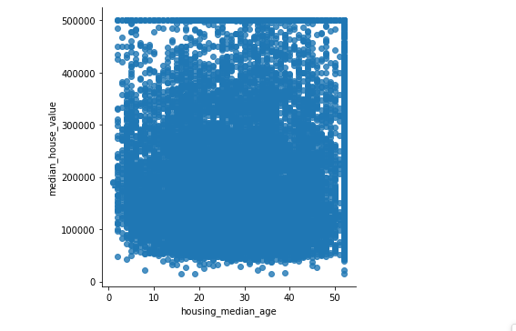 data=train

data=data[['total_rooms','total_bedrooms','housing_median_age','median_income','population','households']]

data.info()

data['total_rooms']=data['total_rooms'].fillna(data['total_rooms'].mean())

data['total_bedrooms']=data['total_bedrooms'].fillna(data['total_bedrooms'].mean())

<class 'pandas.core.frame.DataFrame'>

RangeIndex: 17000 entries, 0 to 16999

Data columns (total 6 columns):

# Column Non-Null Count Dtype

--- ------ -------------- -----

0 total_rooms 17000 non-null float64

1 total_bedrooms 17000 non-null float64

2 housing_median_age 17000 non-null float64

3 median_income 17000 non-null float64

4 population 17000 non-null float64

5 households 17000 non-null float64

dtypes: float64(6)

memory usage: 797.0 KB

<ipython-input-8-2fa8111f12dc>:4: SettingWithCopyWarning:

A value is trying to be set on a copy of a slice from a DataFrame.

Try using .loc[row_indexer,col_indexer] = value instead

See the caveats in the documentation: <https://pandas.pydata.org/pandas-docs/stable/user_guide/indexing.html#returning-a-view-versus-a-copy>

data['total_rooms']=data['total_rooms'].fillna(data['total_rooms'].mean())

<ipython-input-8-2fa8111f12dc>:5: SettingWithCopyWarning:

A value is trying to be set on a copy of a slice from a DataFrame.

Try using .loc[row_indexer,col_indexer] = value instead

See the caveats in the documentation: <https://pandas.pydata.org/pandas-docs/stable/user_guide/indexing.html#returning-a-view-versus-a-copy>

data['total_bedrooms']=data['total_bedrooms'].fillna(data['total_bedrooms'].mean())

train.head()

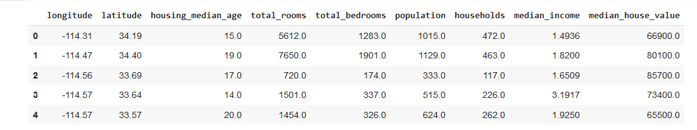 from sklearn.model_selection import train_test_split

y=train.iloc[:,8]

x_train, x_test, y_train, y_test = train_test_split(train, y,test_size=0.2,random_state=0)

print(y.name)

 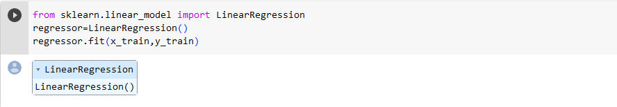 print(regressor.intercept_)

print(regressor.coef_)

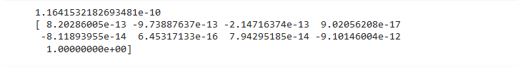 predictions=regressor.predict(x_test)

predictions=predictions.reshape(-1,1)

print(predictions)

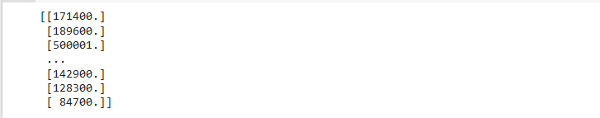 from sklearn.metrics import mean_squared_error

print('MSE:',mean_squared_error(y_test,predictions))

print('RMSE:',np.sqrt(mean_squared_error(y_test,predictions)))

 import numpy as np

arr=np.array([1,2,3,4,5,6,7,8,9,10,11,12])

newarr=arr.reshape(-1,1)

print(newarr)



**Result:**

**EX-7** Develop a program to implement feed-forward neural networks

**Aim:**

To develop a program to implement feed-forward neural networks

**Program:**

import math

import pandas as pd

from keras import models, layers, optimizers, regularizers

import numpy as np

import random

from sklearn import model_selection, preprocessing

import tensorflow as tf

from tqdm import tqdm

import matplotlib.pyplot as plt

file_name = '/content/SAheart.data'

data = pd.read_csv(file_name, sep=',', index_col=0)

data['famhist'] = data['famhist'] == 'Present'

data.head()

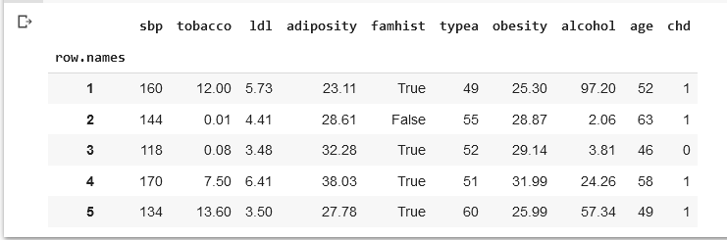 n_test = int(math.ceil(len(data) * 0.3))

random.seed(42)

test_ixs = random.sample(list(range(len(data))), n_test)

train_ixs = [ix for ix in range(len(data)) if ix not in test_ixs]

train = data.iloc[train_ixs, :]

test = data.iloc[test_ixs, :]

print(len(train))

print(len(test))

 #features = ['sbp', 'tobacco', 'ldl', 'adiposity', 'famhist', 'typea', 'obesity', 'alcohol', 'age']

features = ['adiposity', 'age']

response = 'chd'

x_train = train[features]

y_train = train[response]

x_test = test[features]

y_test = test[response]

x_train = preprocessing.normalize(x_train)

x_test = preprocessing.normalize(x_test)

hidden_units = 10     # how many neurons in the hidden layer

activation = 'relu'   # activation function for hidden layer

l2 = 0.01             # regularization - how much we penalize large parameter values

learning_rate = 0.01  # how big our steps are in gradient descent

epochs = 5            # how many epochs to train for

batch_size = 16       # how many samples to use for each gradient descent update

# create a sequential model

model = models.Sequential()

# add the hidden layer

model.add(layers.Dense(input_dim=len(features),

                       units=hidden_units,

                       activation=activation))

# add the output layer

model.add(layers.Dense(input_dim=hidden_units,

                       units=1,

                       activation='sigmoid'))

# define our loss function and optimizer

model.compile(loss='binary_crossentropy',

              # Adam is a kind of gradient descent

              optimizer=optimizers.Adam(lr=learning_rate),

              metrics=['accuracy'])

/usr/local/lib/python3.10/dist-packages/keras/optimizers/legacy/adam.py:117: UserWarning: The `lr` argument is deprecated, use `learning_rate` instead.

super().__init__(name, **kwargs)

# train the parameters

history = model.fit(x_train, y_train, epochs=10, batch_size=batch_size)

# evaluate accuracy

train_acc = model.evaluate(x_train, y_train, batch_size=32)[1]

test_acc = model.evaluate(x_test, y_test, batch_size=32)[1]

print('Training accuracy: %s' % train_acc)

print('Testing accuracy: %s' % test_acc)

losses = history.history['loss']

plt.plot(range(len(losses)), losses, 'r')

plt.show()

### RUN IT AGAIN! ###

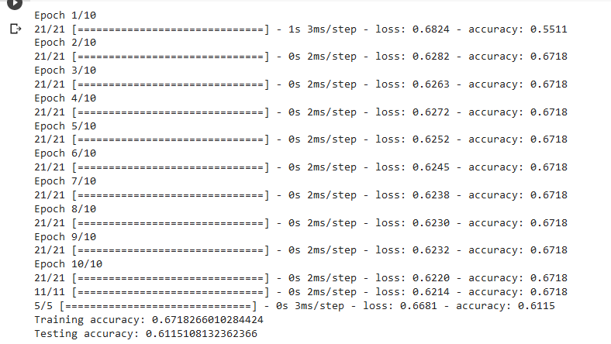 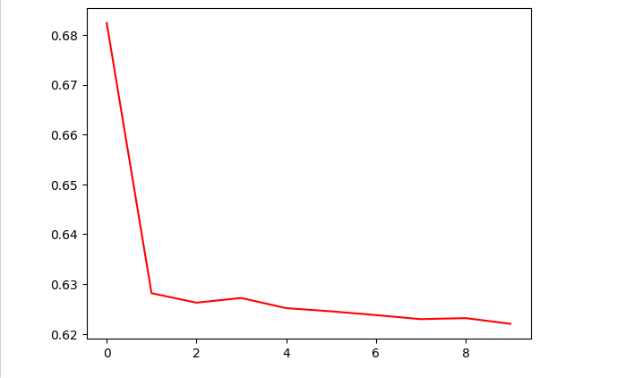

**Result:**

**EX-8** Implement K-means clustering

**Aim:**

To Implement K-means clustering

**Program:**

import numpy as np

import pandas as pd

import matplotlib.pyplot as plt

from sklearn.cluster import  KMeans

import sklearn.metrics as metrics

from google.colab import files

uploaded = files.upload()

 df = pd.read_csv("/content/user1.csv")

df

 x=df.iloc[:,[0,1]].values

print(x)

 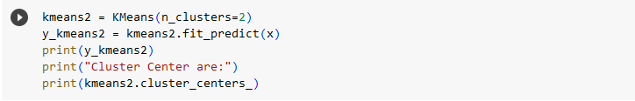

[1 0 0 0 1 1 0 1 0 1]

Cluster Center are:

[[0.488 0.29 ]

[0.248 0.862]]

/usr/local/lib/python3.10/dist-packages/sklearn/cluster/_kmeans.py:870: FutureWarning: The default value of `n_init` will change from 10 to 'auto' in 1.4. Set the value of `n_init` explicitly to suppress the warning

warnings.warn(

plt.scatter(x[:,0],x[:,1],c=y_kmeans2,cmap='viridis')

plt.show()

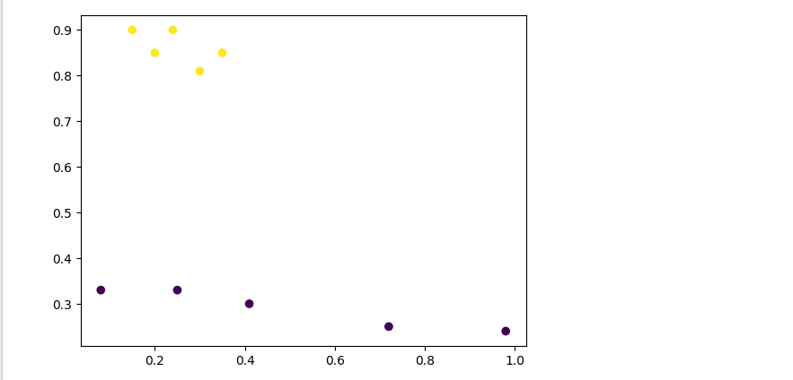

**Result:**

**EX-9** Develop a simple application to demonstrate reinforcement learning

**Aim:**

To develop a simple application to demonstrate reinforcement learning

**Program:**

import gym

env = gym.make("Taxi-v3").env

env.render()

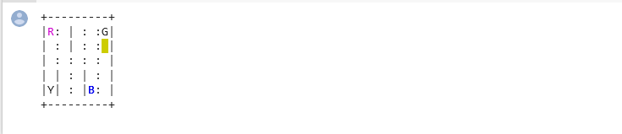

env.reset() # reset environment to a new, random state

env.render()

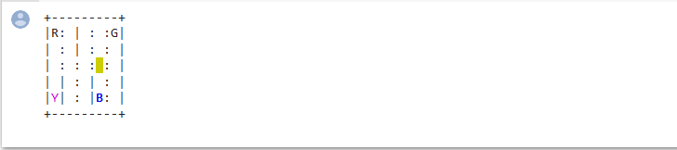

print("Action Space {}".format(env.action_space))

print("State Space {}".format(env.observation_space))



state = env.encode(3, 1, 2, 0) # (taxi row, taxi column, passenger index, destination index)

print("State:", state)



env.s = state

env.render()

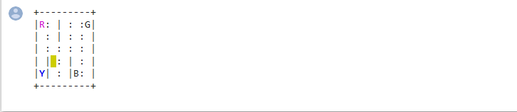

env.P[328]

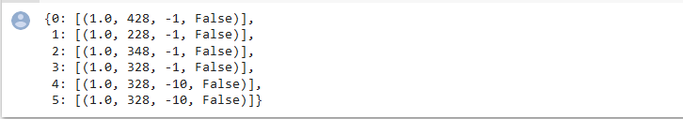

env.s = 328  # set environment to illustration's state

epochs = 0

penalties, reward = 0, 0

frames = [] # for animation

done = False

while not done:

    action = env.action_space.sample()

    state, reward, done, info = env.step(action)

    if reward == -10:

        penalties += 1

    # Put each rendered frame into dict for animation

    frames.append({

        'frame': env.render(mode='ansi'),

        'state': state,

        'action': action,

        'reward': reward

        }

    )

    epochs += 1

print("Timesteps taken: {}".format(epochs))

print("Penalties incurred: {}".format(penalties))



def print_frames(frames):

    for i, frame in enumerate(frames):

        clear_output(wait=True)

        print(frame['frame'])

        print(f"Timestep: {i + 1}")

        print(f"State: {frame['state']}")

        print(f"Action: {frame['action']}")

        print(f"Reward: {frame['reward']}")

        sleep(.1)

print_frames(frames)

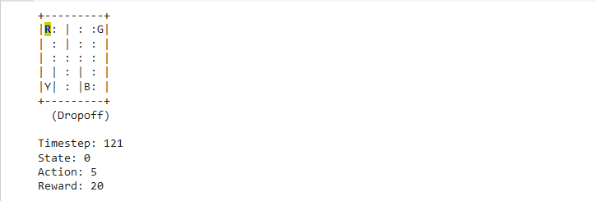

**Result:**

**EX-10** Assess machine learning algorithms using cross validation methods

**Aim:**

To assess machine learning algorithms using cross validation methods

**Program:**

import numpy as np

from sklearn.model_selection import train_test_split

from sklearn.metrics import classification_report

from sklearn import datasets

from sklearn import svm

X, y = datasets.load_iris(return_X_y=True)

X.shape, y.shape



X_train, X_test, y_train, y_test = train_test_split(

  X, y, test_size=0.3, random_state=0)

X_train.shape, y_train.shape

 X_test.shape, y_test.shape

 clf = svm.SVC(kernel='linear', C=1)

clf.fit(X_train, y_train)

 Y_predict = clf.predict(X_test)

print(classification_report(Y_predict,y_test))

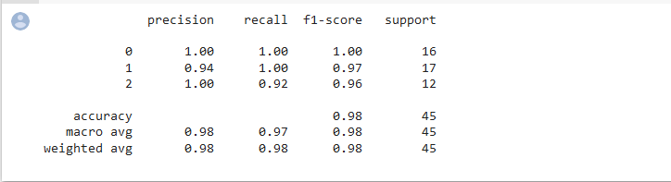 from sklearn.model_selection import cross_val_score

clf = svm.SVC(kernel='linear', C=1, random_state=42)

scores = cross_val_score(clf, X, y, cv=10)

scores

 print("%0.2f accuracy with a standard deviation of %0.2f" % (scores.mean(), scores.std()))



**Result:**